*T*HE SELECTED ISLAMIC E-MAILS OF DR UMAR ELAHI AZAM: *November 2015 CA*

*Electronic Correspondence from the Archive of Dr Azam*

*M*anchester, UK

*D*ecember 2015

[www.dr-umar-azam.com](http://www.dr-umar-azam.com)

[www.dr-umar-azam.co.uk](http://www.dr-umar-azam.co.uk)

<http://dr-umar-azam.weebly.com>

|  |  |
| --- | --- |
| from: | **Abdulhameed manir** <abduolhameedmanir@gmail.com> |
| to: | softcopyofquran@gmail.com (Yes, this is you.) [Learn more](https://support.google.com/mail/answer/10313?hl=en) |
| date: | Sat, Nov 7, 2015 at 8:29 PM |
| subject: |  |
| mailed-by: | gmail.com |
| signed-by: | gmail.com |

**(no subject)**

https://plus.google.com/u/0/_/focus/photos/public/AIbEiAIAAABECMWvpfuV6o6M1gEiC3ZjYXJkX3Bob3RvKihiMWI4Zjk0ODBiMDVlZTZjODJkMGEzNTEyOWRhMjJjMjRhZWIzMmFlMAFIx-X7cJ3mXpuhNuGRLfy4IRqV2g?sz=32

|  |  |  |  |  |
| --- | --- | --- | --- | --- |
| |  | | --- | | **Abdulhameed manir <abduolhameedmanir@gmail.com>** | | Nov 7  https://mail.google.com/mail/u/0/images/cleardot.gif |  | **https://mail.google.com/mail/u/0/images/cleardot.gif**  **https://mail.google.com/mail/u/0/images/cleardot.gif** |
| |  | | --- | | to me  https://mail.google.com/mail/u/0/images/cleardot.gif | | | |

thank you very much.  
am very much grateful for the emails from you and the attached documents.  
may Almighty Allah rewards u and guide us, protect and increase our  
knowledge and iman.

Picture Picture Picture

## washeem has endorsed you!

https://ssl.gstatic.com/ui/v1/icons/mail/profile_mask2.png

|  |  |  |  |  |
| --- | --- | --- | --- | --- |
| |  | | --- | | LinkedIn <messages-noreply@linkedin.com> Unsubscribe | | Nov 9  https://mail.google.com/mail/u/0/images/cleardot.gif |  | **https://mail.google.com/mail/u/0/images/cleardot.gif**  **https://mail.google.com/mail/u/0/images/cleardot.gif** |
| |  | | --- | | to me  https://mail.google.com/mail/u/0/images/cleardot.gif | | | |
| |  | | --- | |  | | | | | | |
| |  |  |  |  |  |  |  |  |  |  |  |  |  |  |  |  |  |  |  |  |  |  |  |  |  |  |  |  |  |  |  |  |  |  |  |  |  |  |  |  |  |  |  |  |  |  |  |  |  |  |  |  |  |  |  |  |  |  |  |  |  |  |  |  |  |  |  |  |  |  |  |  |  |  |  |  |  |  |  |  |  |  |  |  |  |  | | --- | --- | --- | --- | --- | --- | --- | --- | --- | --- | --- | --- | --- | --- | --- | --- | --- | --- | --- | --- | --- | --- | --- | --- | --- | --- | --- | --- | --- | --- | --- | --- | --- | --- | --- | --- | --- | --- | --- | --- | --- | --- | --- | --- | --- | --- | --- | --- | --- | --- | --- | --- | --- | --- | --- | --- | --- | --- | --- | --- | --- | --- | --- | --- | --- | --- | --- | --- | --- | --- | --- | --- | --- | --- | --- | --- | --- | --- | --- | --- | --- | --- | --- | --- | --- | --- | | |  |  |  |  |  |  |  |  |  |  |  |  |  |  |  |  |  |  |  |  |  |  |  |  |  |  |  |  |  |  |  |  |  |  |  |  |  |  |  |  |  |  |  |  |  |  |  | | --- | --- | --- | --- | --- | --- | --- | --- | --- | --- | --- | --- | --- | --- | --- | --- | --- | --- | --- | --- | --- | --- | --- | --- | --- | --- | --- | --- | --- | --- | --- | --- | --- | --- | --- | --- | --- | --- | --- | --- | --- | --- | --- | --- | --- | --- | --- | | |  | | --- | |  |  |  | | --- | |  |  |  | | --- | |  |  |  |  |  |  |  |  | | --- | --- | --- | --- | --- | --- | | |  | | --- | |  | | |  | | --- | |  | | |  | | --- | |  | |  |  |  |  |  |  |  |  |  |  |  |  |  |  |  |  |  |  |  |  |  |  |  |  |  |  |  |  |  |  |  |  |  |  |  |  |  |  | | --- | --- | --- | --- | --- | --- | --- | --- | --- | --- | --- | --- | --- | --- | --- | --- | --- | --- | --- | --- | --- | --- | --- | --- | --- | --- | --- | --- | --- | --- | --- | --- | --- | --- | --- | --- | --- | | |  | | --- | |  | | |  | | --- | |  |  |  | | --- | | Congratulations, QURAN! | | |  | | --- | |  | | | Your connection washeem has endorsed you for skills listed on your profile. Endorsements help show what you're great at. | | |  | | --- | |  | | | |  |  |  |  |  |  | | --- | --- | --- | --- | --- | --- | | |  |  |  |  |  | | --- | --- | --- | --- | --- | | |  | | --- | |  | | [**Continue**](https://www.linkedin.com/comm/profile/edit?showSuggestedEndorsements=true&showPendingEndorsementDialog=false&esl=Strategic+Planning&eslIsEncrypted=f&trk=eml-endrs-khc-btn-off_html&midToken=AQH7okicT9jW5A&trkEmail=eml-endorsements_summary-null-4-null-null-6i21g3%7Eigrjucxc%7E6w) | |  | | --- | |  | | | | | |  | | --- | |  | | | |  | | --- | |  | | | |  |  |  |  |  |  |  |  |  |  |  | | --- | --- | --- | --- | --- | --- | --- | --- | --- | --- | --- | |  | |  | | --- | |  | | |  | | --- | | [washeem Kalideen](https://www.linkedin.com/comm/profile/view?id=AAsAABkXMFcBuPVgLq8zIKdrw5CupN8DCckLxeA&trk=eml-endrs-khc-prof-off_html&midToken=AQH7okicT9jW5A&trkEmail=eml-endorsements_summary-null-10-null-null-6i21g3%7Eigrjucxc%7E6w) **1**st Connected in Sep 2015 | | |  |  | | --- | --- | | |  | | --- | |  | | | Strategic Planning | |  | | --- | |  | | | | | | |  | | --- | |  | | | |  | | --- | |  | | | | |  | | --- | |  | | | |  |  |  |  |  |  |  | | --- | --- | --- | --- | --- | --- | --- | | |  | | --- | |  | | | |  | | --- | |  | | |  | | --- | |  | | | |  | | --- | |  | | |  |  | | --- | --- | | |  | | --- | |  | | | Build your reputation and identity | | |  | | --- | |  | | | Did you know? Only your connections can endorse you, and you can always manage which ones to show. | | [Manage endorsements](https://www.linkedin.com/comm/profile/edit?targetSection=SKIL&_mSplash=1&trk=eml-endrs-kadd-mng-off_html&midToken=AQH7okicT9jW5A&trkEmail=eml-endorsements_summary-null-6-null-null-6i21g3%7Eigrjucxc%7E6w) | | |  | | --- | |  | | | |  | | --- | |  | | |  |  |  |  |  |  |  |  |  |  |  |  |  |  |  | | --- | --- | --- | --- | --- | --- | --- | --- | --- | --- | --- | --- | --- | --- | | |  |  | | --- | --- | | |  | | --- | |  | | | |  | | --- | | © 2015 LinkedIn Ireland Limited. LinkedIn, the LinkedIn logo, and InMail are registered trademarks of LinkedIn Corporation in the United States and/or other countries. All rights reserved. | | |  | | --- | |  | | | You are receiving Endorsements emails. [Unsubscribe](https://www.linkedin.com/e/v2?e=6i21g3-igrjucxc-6w&t=lun&midToken=AQH7okicT9jW5A&tracking=eml-endrs-f-unsub-off_html&ek=endorsements_summary&loid=AQFe22v-5v0KJQAAAVDsWJDkSUBUBubwEUKKmDSbnUBq2ww0LJHlO_S6ieJfFwU0cyesjG2Gccp_BeLPwwJ5G7w&eid=6i21g3-igrjucxc-6w) | | This email was intended for QURAN DISTRIBUTION (RESEARCHER). [Learn why we included this.](https://www.linkedin.com/e/v2?e=6i21g3-igrjucxc-6w&a=customerServiceUrl&midToken=AQH7okicT9jW5A&ek=endorsements_summary&articleId=4788) | | |  | | --- | |  | | | LinkedIn is a registered business name of LinkedIn Ireland Limited. | | Registered in Ireland as a private limited company, Company Number 477441 | | Registered Office: 70 Sir John Rogersons Quay, Dublin 2 | | | | | | | |  |  |

PicturePicturePicture

## Mohammad Iqbal has endorsed you!

https://ssl.gstatic.com/ui/v1/icons/mail/profile_mask2.png

|  |  |  |  |  |
| --- | --- | --- | --- | --- |
| |  | | --- | | LinkedIn <messages-noreply@linkedin.com> Unsubscribe | | Nov 10  https://mail.google.com/mail/u/0/images/cleardot.gif |  | **https://mail.google.com/mail/u/0/images/cleardot.gif**  **https://mail.google.com/mail/u/0/images/cleardot.gif** |
| |  | | --- | | to me  https://mail.google.com/mail/u/0/images/cleardot.gif | | | |
| |  | | --- | |  | | | | | | |
| |  |  |  |  |  |  |  |  |  |  |  |  |  |  |  |  |  |  |  |  |  |  |  |  |  |  |  |  |  |  |  |  |  |  |  |  |  |  |  |  |  |  |  |  |  |  |  |  |  |  |  |  |  |  |  |  |  |  |  |  |  |  |  |  |  |  |  |  |  |  |  |  |  |  |  |  |  |  |  |  |  |  |  |  |  |  | | --- | --- | --- | --- | --- | --- | --- | --- | --- | --- | --- | --- | --- | --- | --- | --- | --- | --- | --- | --- | --- | --- | --- | --- | --- | --- | --- | --- | --- | --- | --- | --- | --- | --- | --- | --- | --- | --- | --- | --- | --- | --- | --- | --- | --- | --- | --- | --- | --- | --- | --- | --- | --- | --- | --- | --- | --- | --- | --- | --- | --- | --- | --- | --- | --- | --- | --- | --- | --- | --- | --- | --- | --- | --- | --- | --- | --- | --- | --- | --- | --- | --- | --- | --- | --- | --- | | |  |  |  |  |  |  |  |  |  |  |  |  |  |  |  |  |  |  |  |  |  |  |  |  |  |  |  |  |  |  |  |  |  |  |  |  |  |  |  |  |  |  |  |  |  |  |  | | --- | --- | --- | --- | --- | --- | --- | --- | --- | --- | --- | --- | --- | --- | --- | --- | --- | --- | --- | --- | --- | --- | --- | --- | --- | --- | --- | --- | --- | --- | --- | --- | --- | --- | --- | --- | --- | --- | --- | --- | --- | --- | --- | --- | --- | --- | --- | | |  | | --- | |  |  |  | | --- | |  |  |  | | --- | |  |  |  |  |  |  |  |  | | --- | --- | --- | --- | --- | --- | | |  | | --- | |  | | |  | | --- | |  | | |  | | --- | |  | |  |  |  |  |  |  |  |  |  |  |  |  |  |  |  |  |  |  |  |  |  |  |  |  |  |  |  |  |  |  |  |  |  |  |  |  |  |  | | --- | --- | --- | --- | --- | --- | --- | --- | --- | --- | --- | --- | --- | --- | --- | --- | --- | --- | --- | --- | --- | --- | --- | --- | --- | --- | --- | --- | --- | --- | --- | --- | --- | --- | --- | --- | --- | | |  | | --- | |  | | |  | | --- | |  |  |  | | --- | | Congratulations, QURAN! | | |  | | --- | |  | | | Your connection Mohammad Iqbal has endorsed you for skills listed on your profile. Endorsements help show what you're great at. | | |  | | --- | |  | | | |  |  |  |  |  |  | | --- | --- | --- | --- | --- | --- | | |  |  |  |  |  | | --- | --- | --- | --- | --- | | |  | | --- | |  | | [**Continue**](https://www.linkedin.com/comm/profile/edit?showSuggestedEndorsements=true&showPendingEndorsementDialog=false&esl=Analysis&eslIsEncrypted=f&trk=eml-endrs-khc-btn-off_html&midToken=AQH7okicT9jW5A&trkEmail=eml-endorsements_summary-null-4-null-null-6i21g3%7Eigsycudp%7E0) | |  | | --- | |  | | | | | |  | | --- | |  | | | |  | | --- | |  | | | |  |  |  |  |  |  |  |  |  |  |  | | --- | --- | --- | --- | --- | --- | --- | --- | --- | --- | --- | |  | |  | | --- | |  | | |  | | --- | | [Mohammad Iqbal Abubaker](https://www.linkedin.com/comm/profile/view?id=AAsAAAOzYrgBdX7dovchcyFygmBPrTe5g5IWdAc&trk=eml-endrs-khc-prof-off_html&midToken=AQH7okicT9jW5A&trkEmail=eml-endorsements_summary-null-10-null-null-6i21g3%7Eigsycudp%7E0) **1**st Connected in Jun 2015 | | |  |  | | --- | --- | | |  | | --- | |  | | | Analysis | |  | | --- | |  | | | | | | |  | | --- | |  | | | |  | | --- | |  | | | | |  | | --- | |  | | | |  |  |  |  |  |  |  | | --- | --- | --- | --- | --- | --- | --- | | |  | | --- | |  | | | |  | | --- | |  | | |  | | --- | |  | | | |  | | --- | |  | | |  |  | | --- | --- | | |  | | --- | |  | | | Build your reputation and identity | | |  | | --- | |  | | | Did you know? Only your connections can endorse you, and you can always manage which ones to show. | | [Manage endorsements](https://www.linkedin.com/comm/profile/edit?targetSection=SKIL&_mSplash=1&trk=eml-endrs-kadd-mng-off_html&midToken=AQH7okicT9jW5A&trkEmail=eml-endorsements_summary-null-6-null-null-6i21g3%7Eigsycudp%7E0) | | |  | | --- | |  | | | |  | | --- | |  | | |  |  |  |  |  |  |  |  |  |  |  |  |  |  |  | | --- | --- | --- | --- | --- | --- | --- | --- | --- | --- | --- | --- | --- | --- | | |  |  | | --- | --- | | |  | | --- | |  | | | |  | | --- | | © 2015 LinkedIn Ireland Limited. LinkedIn, the LinkedIn logo, and InMail are registered trademarks of LinkedIn Corporation in the United States and/or other countries. All rights reserved. | | |  | | --- | |  | | | You are receiving Endorsements emails. [Unsubscribe](https://www.linkedin.com/e/v2?e=6i21g3-igsycudp-0&t=lun&midToken=AQH7okicT9jW5A&tracking=eml-endrs-f-unsub-off_html&ek=endorsements_summary&loid=AQFYpyWmEe6eQAAAAVDxtYJuGm0fhlxJuLH-ETgMT0oRFpArmz5ng-30AM_ONkwDoJ5r3Rte4R0CgXOv9EDfeEM&eid=6i21g3-igsycudp-0) | | This email was intended for QURAN DISTRIBUTION (RESEARCHER). [Learn why we included this.](https://www.linkedin.com/e/v2?e=6i21g3-igsycudp-0&a=customerServiceUrl&midToken=AQH7okicT9jW5A&ek=endorsements_summary&articleId=4788) | | |  | | --- | |  | | | LinkedIn is a registered business name of LinkedIn Ireland Limited. | | Registered in Ireland as a private limited company, Company Number 477441 | | Registered Office: 70 Sir John Rogersons Quay, Dublin 2 | | | | | | | |  |  |

PicturePicturePicture

|  |  |  |  |  |
| --- | --- | --- | --- | --- |
| |  | | --- | | **Mohd Maqbool Lone** | | Nov 17  https://mail.google.com/mail/u/0/images/cleardot.gif |  | **https://mail.google.com/mail/u/0/images/cleardot.gif**  **https://mail.google.com/mail/u/0/images/cleardot.gif** |
| |  | | --- | | to me  https://mail.google.com/mail/u/0/images/cleardot.gif | | | |

Asalamu alaykum ,  
miss u a lot brouher.how r u and whats is going on nowbz,pls inform  
with regards,  
M.MAQBOOL

https://plus.google.com/u/0/_/focus/photos/public/AIbEiAIAAABECIfHp4zPp4qBwwEiC3ZjYXJkX3Bob3RvKig5OGRjZjUwNWQ0NjE5NDVjZmU3NjI0NTllNjk2NDM3YWUxOGI4MWVlMAGXVhmPSPWMFFwNLX63EZeKAv5fxw?sz=32

|  |  |  |  |  |
| --- | --- | --- | --- | --- |
| |  | | --- | | **QURAN DISTRIBUTION <softcopyofquran@googlemail.com>** | | AttachmentsNov 17  https://mail.google.com/mail/u/0/images/cleardot.gif |  | **https://mail.google.com/mail/u/0/images/cleardot.gif**  **https://mail.google.com/mail/u/0/images/cleardot.gif** |
| |  | | --- | | to Mohd  https://mail.google.com/mail/u/0/images/cleardot.gif | | | |

**WA LAIKUM SALAM,**

**JUST PUSHING ON WITH HARD WORK, BR MAQBOOL.  PLEASE SEE ATTACHED FILE OF ME HELPING SOMEONE IN MAURITIUS TO CHECK THE HALAL INGREDIENTS OF BISCUITS IMPORTED FROM MAURITIUS.**

**SALAM & DUA**

**DR UMAR**

**Correspondence Concerning *Consolidated Biscuits’* Bourbon Creams**

**From the Archive of Dr Umar Elahi Azam**

**Manchester, UK**

**November 2015**

RE: Devon Bourbon creams

Important

* [**Hussain Mamode**<mamode.hussain@gmail.com>](https://uk-mg42.mail.yahoo.com/neo/launch?.rand=c4o90hou2t94d)

* Nov 12 at 7:14 AM

To

* Dr Umar Azam

Message body

Brother Umar,

 I hot your email while searching for halal confirmation on the internet. Unfortunately i did not receive the Islamic resources you sent. Vould you please forward them to me?

Brother please find attached the email response i received today. When you get a feedback please keep ne updated.

JaazakAllah Khair.

Hussain Mamode

Devon Bourbon creams

Picture

Important

* [**Hussain Mamode**<mamode.hussain@gmail.com>](https://uk-mg42.mail.yahoo.com/neo/launch?.rand=c4o90hou2t94d)

* Nov 11 at 12:51 AM

To

* dr_umar_azam@yahoo.co.uk

Message body

Assalaamualaikum Wa Rahmatullahi Wa Barakaatuh.

Dear Brother,

I have doubts concerning the “vanilla flavour” in a biscuit named “Bourbon Creams” of the brand “Devon”.

The company manufacturing the biscuits is ***Consolidated Biscuits co. Ltd.***

Here is a link to the product:    <http://www.cbiscuits.com/Our_Brands/devon>

Please help me in knowing if the vanilla flavor used has been extracted with alcohol or if it is Halal.

JazaakAllah Khair brother, May Allah bless you,

Regards,

Hussain Mamode

|  |  |
| --- | --- |
| [Avast logo](https://www.avast.com/antivirus) | This email has been checked for viruses by Avast antivirus software.  [www.avast.com](https://www.avast.com/antivirus) |

Picture

**From:** [Dr Umar Azam](mailto:dr_umar_azam@yahoo.co.uk)

**To:** [ameilak@cbiscuits.com](mailto:ameilak@cbiscuits.com)

**Sent:** Wednesday, November 11, 2015 3:00 AM

**Subject:** FW: Devon Bourbon creams

Dear Sir or Madam

Please see the forwarded email and give me your reply so that I can inform my correspondent.

Kind regards,

Dr  Umar   
[www.dr-umar-azam.com](http://www.dr-umar-azam.com/)

Sent from my Sony Xperia™ smartphone

Picture

Re: Devon Bourbon creams

* [**Annelyse Bartolo**<annelysebartolo@cbiscuits.com>](https://uk-mg42.mail.yahoo.com/neo/launch?.rand=c4o90hou2t94d)

* Nov 12 at 11:15 AM

To

* Dr Umar Azam

Message body

Dear Dr Umar,

Thanks for your query, kindly note that Mr. Alex Meilak does not work at Consolidated Biscuit any more.

In the meantime we are working on your request and will reply shortly.

Kind Regards,

Annelyse Bartolo

Technical Manager  
Consolidated Biscuit Co. Ltd.

Tel. No. +356 21440361  
Dir. Line +356 23817138

Picture

From: Dr Umar Azam <dr_umar_azam@yahoo.co.uk>   
Date: 12/11/2015 10:22 (GMT+04:00)   
To: Hussain Mamode <mamode.hussain@gmail.com>   
Subject: RE: Devon Bourbon creams 

Wa laikum salam, Br Hussain

Thank you for your enquiry which I have forwarded to the Head Office of Consolidated Biscuits in Malta. When I am given a reply by them, I will divulge the information to you; hoping the filling will inshallah be halal so That you can consume them with enjoyment.

Br Hussain, which country are you in?  And did you get all those emailed Islamic resources I sent you?

Dr Umar

Sent from my Sony Xperia™ smartphone

Picture

RE: Devon Bourbon creams

Important

* [**Hussain Mamode**<mamode.hussain@gmail.com>](https://uk-mg42.mail.yahoo.com/neo/launch?.rand=c4o90hou2t94d)

* Nov 12 at 12:18 PM

To

* Dr Umar Azam

Message body

I am from Mauritius brother.

Hussain Mamode

Picture

Re: Devon Bourbon creams

* [**Annelyse Bartolo**<annelysebartolo@cbiscuits.com>](https://uk-mg42.mail.yahoo.com/neo/launch?.rand=c4o90hou2t94d)

* Nov 16 at 9:00 AM

To

* Dr Umar Azam

CC

* mamode.hussain@gmail.com

* vdeguara@cbiscuits.com

Message body

Dear Dr. Umar,

Kindly note that the vanilla flavours used in the Devon Bourbon Creams are both Halal.

Please refer to the documents attached.

Kind Regards,

Annelyse Bartolo

Technical Manager  
Consolidated Biscuit Co. Ltd.

Tel. No. +356 21440361  
Dir. Line +356 23817138





**INTERNATIONAL FLAVORS AND FRAGRANCES INC.**

IFF Code/Customer Code: 15811902 / 15811902

Description: VANILLA FLAVOR LIQUID

**HALAL STATEMENT**

We herewith declare that this product conforms to the following requirements:

1. The product does not contain ingredients of animal origin that are not permitted according to the religious requirements.
2. The product does not contain ethanol that is not permitted according to the religious requirements.
3. The equipment used for manufacturing this material is not used for the manufacture of other products that are not permitted according to the religious requirements, or has been adequately cleaned to prevent contamination by such non-permitted products.

This is a computer generated document and is therefore not signed.

16 - Nov - 2015

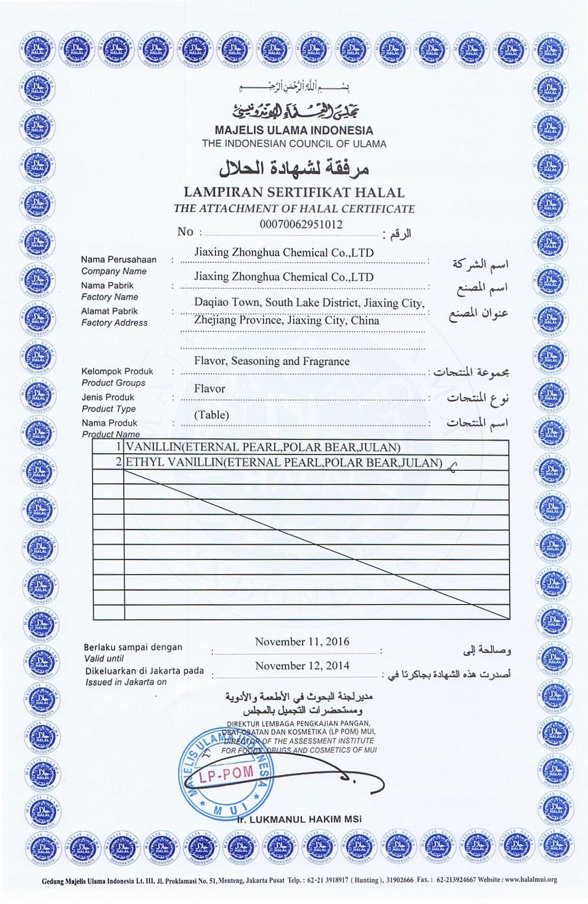

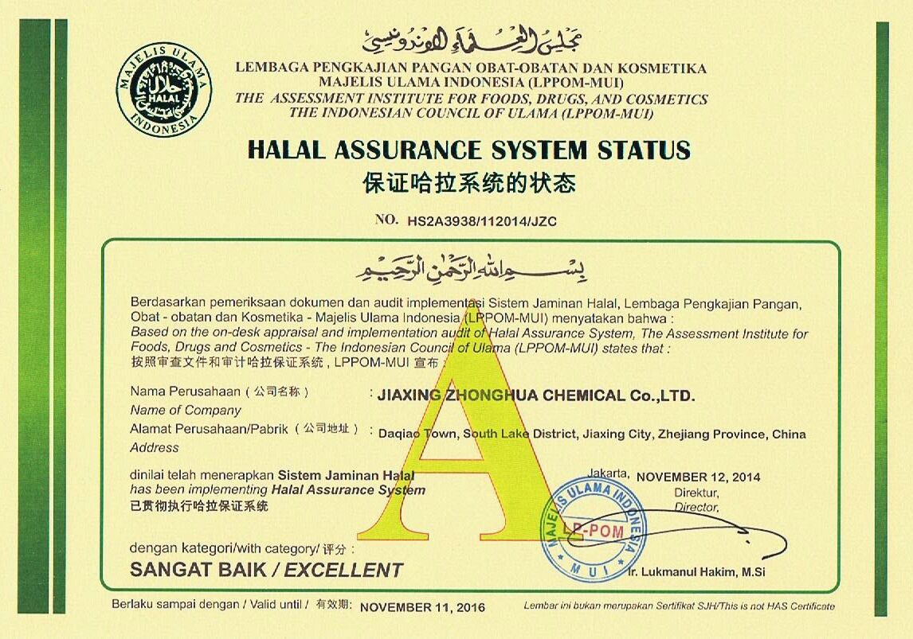

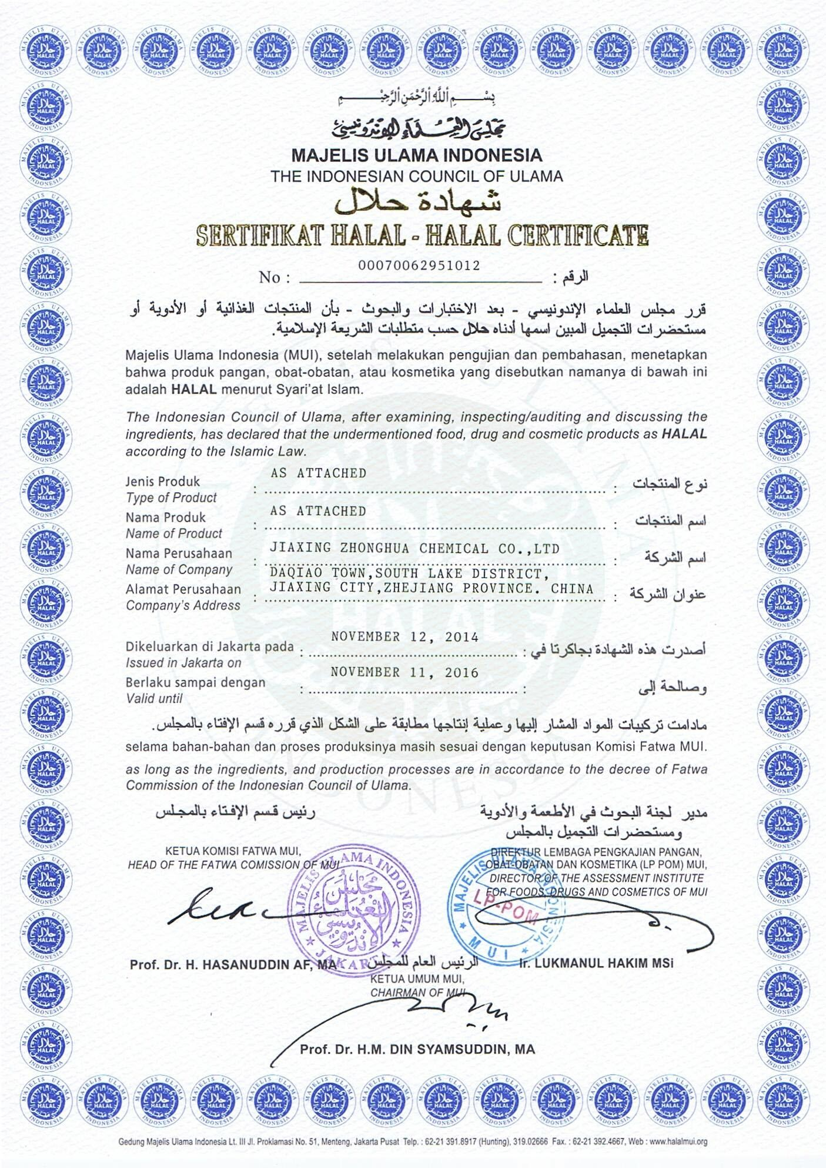

Picture

Re: Devon Bourbon creams

Important

* [**Hussain Mamode**<mamode.hussain@gmail.com>](https://uk-mg42.mail.yahoo.com/neo/launch?.rand=c4o90hou2t94d)

* Nov 16 at 10:33 AM

To

* Annelyse Bartolo

* Dr Umar Azam

CC

* vdeguara@cbiscuits.com

Message body

Dear Madam,

Thank you very much for your confirmation.

Best regards,

Hussain Mamode

Picture

Re: Devon Bourbon creams

* [**Dr Umar Azam**<dr_umar_azam@yahoo.co.uk>](https://uk-mg42.mail.yahoo.com/neo/launch?.rand=c4o90hou2t94d)

* Nov 16 at 1:11 PM

To

* Annelyse Bartolo

CC

* mamode.hussain@gmail.com

* vdeguara@cbiscuits.com

Message body

Dear Annelyse Bartolo,

Thanks so much for your confirmation.

And now that we know, Br Mamode, please do enjoy the biscuits yourself and be happy to recommend them to other friends, relatives and contacts in your locality.

Kind regards,  
Dr Umar

Sent from my Sony Xperia™ smartphone

Re: Devon Bourbon creams

* [**Dr Umar Azam**<dr_umar_azam@yahoo.co.uk>](https://uk-mg42.mail.yahoo.com/neo/launch?.rand=c4o90hou2t94d)

* Nov 16 at 1:24 PM

To

* Annelyse Bartolo

* Hussain Mamode

CC

* vdeguara@cbiscuits.com

Message body

PS

That locality being Mauritius and the biscuits being imported from Malta  (I myself being  in the UK and residing n Manchester have not seen Consolidated Biscuits'  products in my own city but a/guess hat outlets in London might stock the Brand).

Sent from my Sony Xperia™ smartphone

|  |  |  |  |  |
| --- | --- | --- | --- | --- |
| |  | | --- | | Mohd Maqbool Lone | | Nov 18  https://mail.google.com/mail/u/0/images/cleardot.gif |  | **https://mail.google.com/mail/u/0/images/cleardot.gif**  **https://mail.google.com/mail/u/0/images/cleardot.gif** |
| |  | | --- | | to me  https://mail.google.com/mail/u/0/images/cleardot.gif | | | |

Tnx Allah,how bout ur work? Do u recieve help from the sheikh or not ?  
I dont have any one from mauritious brother.May Allah bless u  
regards,  
M.Maqbool

https://plus.google.com/u/0/_/focus/photos/public/AIbEiAIAAABECIfHp4zPp4qBwwEiC3ZjYXJkX3Bob3RvKig5OGRjZjUwNWQ0NjE5NDVjZmU3NjI0NTllNjk2NDM3YWUxOGI4MWVlMAGXVhmPSPWMFFwNLX63EZeKAv5fxw?sz=32

|  |  |  |  |  |
| --- | --- | --- | --- | --- |
| |  | | --- | | Dr Umar Azam <softcopyofquran@gmail.com> | | Nov 18  https://mail.google.com/mail/u/0/images/cleardot.gif |  | **https://mail.google.com/mail/u/0/images/cleardot.gif**  **https://mail.google.com/mail/u/0/images/cleardot.gif** |
| |  | | --- | | to Mohd  https://mail.google.com/mail/u/0/images/cleardot.gif | | | |

https://ssl.gstatic.com/ui/v1/icons/mail/images/cleardot.gif

I've forgotten about the sheikh because he isn't going to help me. Allah Hafiz.  
  
Sent from my Sony Xperia™ smartphone

https://plus.google.com/u/0/_/focus/photos/public/AIbEiAIAAABECIfHp4zPp4qBwwEiC3ZjYXJkX3Bob3RvKig5OGRjZjUwNWQ0NjE5NDVjZmU3NjI0NTllNjk2NDM3YWUxOGI4MWVlMAGXVhmPSPWMFFwNLX63EZeKAv5fxw?sz=32

|  |  |  |  |  |
| --- | --- | --- | --- | --- |
| |  | | --- | | Dr Umar Azam <softcopyofquran@gmail.com> | | Nov 18  https://mail.google.com/mail/u/0/images/cleardot.gif |  | **https://mail.google.com/mail/u/0/images/cleardot.gif**  **https://mail.google.com/mail/u/0/images/cleardot.gif** |
| |  | | --- | | to Mohd  https://mail.google.com/mail/u/0/images/cleardot.gif | | | |

https://ssl.gstatic.com/ui/v1/icons/mail/images/cleardot.gif

I've forgotten about the sheikh because he isn't going to help me. Allah Hafiz.  
  
Sent from my Sony Xperia™ smartphone

|  |  |  |  |  |
| --- | --- | --- | --- | --- |
| |  | | --- | | Mohd Maqbool Lone | | Nov 18  https://mail.google.com/mail/u/0/images/cleardot.gif |  | **https://mail.google.com/mail/u/0/images/cleardot.gif**  **https://mail.google.com/mail/u/0/images/cleardot.gif** |
| |  | | --- | | to me  https://mail.google.com/mail/u/0/images/cleardot.gif | | | |

Search for other sources,may be you can found the ways

|  |  |  |  |  |
| --- | --- | --- | --- | --- |
| |  | | --- | | Mohd Maqbool Lone | | Nov 18  https://mail.google.com/mail/u/0/images/cleardot.gif |  | **https://mail.google.com/mail/u/0/images/cleardot.gif**  **https://mail.google.com/mail/u/0/images/cleardot.gif** |
| |  | | --- | | to me  https://mail.google.com/mail/u/0/images/cleardot.gif | | | |

Search for other sources,may be you can found the ways

PicturePicturePicture

## Request the free Holy Quran & Islamic resources eg Family Tree of Muhammad S.A.W.; Islamic Calendar

|  |  |
| --- | --- |
| [Imap]/Sent | x |

https://plus.google.com/u/0/_/focus/photos/public/AIbEiAIAAABECOaZwb7O0M61lQEiC3ZjYXJkX3Bob3RvKig1YmM4ZTI1OTc4MzIxYzZkYWYzZGQyM2U4YzI5MDdjOWVmNzI0NjMxMAEttkQZOjP4Je7_Btuv_uJFY-03nw?sz=32

|  |  |  |  |  |
| --- | --- | --- | --- | --- |
| |  | | --- | | shoaib momin <shbmomin15@gmail.com> | | Jul 14  https://mail.google.com/mail/u/0/images/cleardot.gif |  | **https://mail.google.com/mail/u/0/images/cleardot.gif**  **https://mail.google.com/mail/u/0/images/cleardot.gif** |
| |  | | --- | | to me  https://mail.google.com/mail/u/0/images/cleardot.gif | | | |

Request the free Holy Quran in hindi language.

## **sent several other valuable Islamic resources eg Family Tree of Muhammad S.A.W.; Islamic Calendar. other Useful book on islam send. on my address billow..**

name : shoaib momin

gujarat,india)

https://plus.google.com/u/0/_/focus/photos/public/AIbEiAIAAABECIfHp4zPp4qBwwEiC3ZjYXJkX3Bob3RvKig5OGRjZjUwNWQ0NjE5NDVjZmU3NjI0NTllNjk2NDM3YWUxOGI4MWVlMAGXVhmPSPWMFFwNLX63EZeKAv5fxw?sz=32

|  |  |  |  |  |
| --- | --- | --- | --- | --- |
| |  | | --- | | QURAN DISTRIBUTION <softcopyofquran@googlemail.com> | | Jul 14  https://mail.google.com/mail/u/0/images/cleardot.gif |  | **https://mail.google.com/mail/u/0/images/cleardot.gif**  **https://mail.google.com/mail/u/0/images/cleardot.gif** |
| |  | | --- | | to mohamedshrok20., Burhan, shbmomin15  https://mail.google.com/mail/u/0/images/cleardot.gif | | | |

**SALAM, BRS SALAH AND BURHAN**

**PLEASE SEND THE HOLY QURAN AND ISLAMIC BOOKS TO BR SHOAIB IN INDIA [PLEASE SEE FORWARDED MAIL]**

**DR UMAR**

https://ssl.gstatic.com/ui/v1/icons/mail/images/cleardot.gif

https://plus.google.com/u/0/_/focus/photos/public/AIbEiAIAAABECOaZwb7O0M61lQEiC3ZjYXJkX3Bob3RvKig1YmM4ZTI1OTc4MzIxYzZkYWYzZGQyM2U4YzI5MDdjOWVmNzI0NjMxMAEttkQZOjP4Je7_Btuv_uJFY-03nw?sz=32

|  |  |  |  |  |
| --- | --- | --- | --- | --- |
| |  | | --- | | shoaib momin <shbmomin15@gmail.com> | | Aug 26  https://mail.google.com/mail/u/0/images/cleardot.gif |  | **https://mail.google.com/mail/u/0/images/cleardot.gif**  **https://mail.google.com/mail/u/0/images/cleardot.gif** |
| |  | | --- | | to me  https://mail.google.com/mail/u/0/images/cleardot.gif | | | |

salam, BR UMAR till date not received islamic books yet.

ASAP sir.

https://ssl.gstatic.com/ui/v1/icons/mail/images/cleardot.gif

https://plus.google.com/u/0/_/focus/photos/public/AIbEiAIAAABECIfHp4zPp4qBwwEiC3ZjYXJkX3Bob3RvKig5OGRjZjUwNWQ0NjE5NDVjZmU3NjI0NTllNjk2NDM3YWUxOGI4MWVlMAGXVhmPSPWMFFwNLX63EZeKAv5fxw?sz=32

|  |  |  |  |  |
| --- | --- | --- | --- | --- |
| |  | | --- | | Dr Umar Azam <softcopyofquran@googlemail.com> | | Aug 26  https://mail.google.com/mail/u/0/images/cleardot.gif |  | **https://mail.google.com/mail/u/0/images/cleardot.gif**  **https://mail.google.com/mail/u/0/images/cleardot.gif** |
| |  | | --- | | to mohamedshrok20., Burhan, shbmomin15  https://mail.google.com/mail/u/0/images/cleardot.gif | | | |

Salam, Brs Salah and Burhan

Please see forwarded message

Jazakallah

Dr Umar

Sent from my Sony Xperia™ smartphone

https://ssl.gstatic.com/ui/v1/icons/mail/images/cleardot.gif

https://plus.google.com/u/0/_/focus/photos/public/AIbEiAIAAABECIfHp4zPp4qBwwEiC3ZjYXJkX3Bob3RvKig5OGRjZjUwNWQ0NjE5NDVjZmU3NjI0NTllNjk2NDM3YWUxOGI4MWVlMAGXVhmPSPWMFFwNLX63EZeKAv5fxw?sz=32

|  |  |  |  |  |
| --- | --- | --- | --- | --- |
| |  | | --- | | Dr Umar Azam <softcopyofquran@gmail.com> | | Aug 26  https://mail.google.com/mail/u/0/images/cleardot.gif |  | **https://mail.google.com/mail/u/0/images/cleardot.gif**  **https://mail.google.com/mail/u/0/images/cleardot.gif** |
| |  | | --- | | to mohamedshrok20., Burhan, shbmomin15  https://mail.google.com/mail/u/0/images/cleardot.gif | | | |

https://ssl.gstatic.com/ui/v1/icons/mail/images/cleardot.gif

Salam, Brs Salah and Burhan  
  
Please see forwarded message  
  
Jazakallah  
  
Dr Umar  
  
Sent from my Sony Xperia™ smartphone  
  
---- Original Message ----  
Subject: Re: Request the free Holy Quran & Islamic resources eg Family Tree of Muhammad S.A.W.; Islamic Calendar  
Sent: 26 Aug 2015 08:46  
From: shoaib momin <[shbmomin15@gmail.com](mailto:shbmomin15@gmail.com)>  
To: QURAN DISTRIBUTION <[softcopyofquran@googlemail.com](mailto:softcopyofquran@googlemail.com)>  
Cc:  
  
> salam, BR UMAR till date not received islamic books yet.  
>  
>  
> ASAP sir.  
> On Wed, Jul 15, 2015 at 3:34 AM, QURAN DISTRIBUTION <[softcopyofquran@googlemail.com](mailto:softcopyofquran@googlemail.com)> wrote:  
>  
> SALAM, BRS SALAH AND BURHAN  
>  
>  
> PLEASE SEND THE HOLY QURAN AND ISLAMIC BOOKS TO BR SHOAIB IN INDIA [PLEASE SEE FORWARDED MAIL]  
>  
>  
> DR UMAR  
>  
>  
>  
> ---------- Forwarded message ----------  
> From: shoaib momin <[shbmomin15@gmail.com](mailto:shbmomin15@gmail.com)>  
> Date: Tue, Jul 14, 2015 at 11:20 AM  
> Subject: Request the free Holy Quran & Islamic resources eg Family Tree of Muhammad S.A.W.; Islamic Calendar  
> To: [softcopyofquran@gmail.com](mailto:softcopyofquran@gmail.com)  
>  
>  
> Request the free Holy Quran in hindi language. sent several other valuable Islamic resources eg Family Tree of Muhammad S.A.W.; Islamic Calendar. other Useful book on islam send. on my address billow..  
>  
> name : shoaib momin  
>  
> add: near vallabha nagar police chokey, opp jain mandir nadiad-387002 (kheda,gujarat,india)

https://ssl.gstatic.com/ui/v1/icons/mail/profile_mask2.png

|  |  |  |  |  |
| --- | --- | --- | --- | --- |
| |  | | --- | | mohamed salah <mohamedshrok2005@yahoo.com> | | Aug 26  https://mail.google.com/mail/u/0/images/cleardot.gif |  | **https://mail.google.com/mail/u/0/images/cleardot.gif**  **https://mail.google.com/mail/u/0/images/cleardot.gif** |
| |  | | --- | | to me  https://mail.google.com/mail/u/0/images/cleardot.gif | | | |

ok My dear brother, May Allah reward you :)

MashaAllah

**There is no god but Allah**

**and Mohamed is the messenger of Allah**

**for free islamic books down load**

**http://**[**www.islamic-invitation.com**](http://www.islamic-invitation.com/)

**The biggest Site for Muslim and Christian Dialogue**

[**http://www.chatislamonline.org**](http://www.chatislamonline.org/)

[**mohamedshrok2005@yahoo.com**](mailto:mohamedshrok2005@yahoo.com)

[**mohamedshrok@hotmail.com**](mailto:mohamedshrok@hotmail.com)

**my mobile**

[**( +201220642936**](tel:%28%20%2B201220642936)**)**

https://ssl.gstatic.com/ui/v1/icons/mail/images/cleardot.gif

https://plus.google.com/u/0/_/focus/photos/public/AIbEiAIAAABECOaZwb7O0M61lQEiC3ZjYXJkX3Bob3RvKig1YmM4ZTI1OTc4MzIxYzZkYWYzZGQyM2U4YzI5MDdjOWVmNzI0NjMxMAEttkQZOjP4Je7_Btuv_uJFY-03nw?sz=32

|  |  |  |  |  |
| --- | --- | --- | --- | --- |
| |  | | --- | | shoaib momin | | Nov 18  https://mail.google.com/mail/u/0/images/cleardot.gif |  | **https://mail.google.com/mail/u/0/images/cleardot.gif**  **https://mail.google.com/mail/u/0/images/cleardot.gif** |
| |  | | --- | | to me  https://mail.google.com/mail/u/0/images/cleardot.gif | | | |

## **send Islamic Calendar. other Useful book on islam send. on my address billow..**

PicturePicturePicture

## Soft Copy of Quran

https://ssl.gstatic.com/ui/v1/icons/mail/profile_mask2.png

|  |  |  |  |  |
| --- | --- | --- | --- | --- |
| |  | | --- | | Oluwaseun Sofoluwe <sofoluwe2002@yahoo.com> | | Nov 28 (4 days ago)  https://mail.google.com/mail/u/0/images/cleardot.gif |  | **https://mail.google.com/mail/u/0/images/cleardot.gif**  **https://mail.google.com/mail/u/0/images/cleardot.gif** |
| |  | | --- | | to me  https://mail.google.com/mail/u/0/images/cleardot.gif | | | |

Dear Sir

Kindly send me soft copy of Holy Quaran for my easy use

Regards

PicturePicturePicture

## Soft Copy of Quran

|  |  |
| --- | --- |
| Inbox | x |

|  |  |
| --- | --- |
| [Imap]/Sent | x |

https://ssl.gstatic.com/ui/v1/icons/mail/profile_mask2.png

|  |  |  |  |  |
| --- | --- | --- | --- | --- |
| |  | | --- | | Oluwaseun Sofoluwe <sofoluwe2002@yahoo.com> | | Nov 29 (3 days ago)  https://mail.google.com/mail/u/0/images/cleardot.gif |  | **https://mail.google.com/mail/u/0/images/cleardot.gif**  **https://mail.google.com/mail/u/0/images/cleardot.gif** |
| |  | | --- | | to me  https://mail.google.com/mail/u/0/images/cleardot.gif | | | |

Dear Sir

Kindly send me soft copy of Quran in English Language.

Regards

https://ssl.gstatic.com/ui/v1/icons/mail/images/cleardot.gif

https://plus.google.com/u/0/_/focus/photos/public/AIbEiAIAAABECIfHp4zPp4qBwwEiC3ZjYXJkX3Bob3RvKig5OGRjZjUwNWQ0NjE5NDVjZmU3NjI0NTllNjk2NDM3YWUxOGI4MWVlMAGXVhmPSPWMFFwNLX63EZeKAv5fxw?sz=32

|  |  |  |  |  |
| --- | --- | --- | --- | --- |
| |  | | --- | | Dr Umar Azam <softcopyofquran@googlemail.com> | | Nov 29 (3 days ago)  https://mail.google.com/mail/u/0/images/cleardot.gif |  | **https://mail.google.com/mail/u/0/images/cleardot.gif**  **https://mail.google.com/mail/u/0/images/cleardot.gif** |
| |  | | --- | | to Oluwaseun  https://mail.google.com/mail/u/0/images/cleardot.gif | | | |

Already sent a few hours ago, Br Sofoluwe

Sent from my Sony Xperia™ smartphone

https://plus.google.com/u/0/_/focus/photos/public/AIbEiAIAAABECIfHp4zPp4qBwwEiC3ZjYXJkX3Bob3RvKig5OGRjZjUwNWQ0NjE5NDVjZmU3NjI0NTllNjk2NDM3YWUxOGI4MWVlMAGXVhmPSPWMFFwNLX63EZeKAv5fxw?sz=32

|  |  |  |  |  |
| --- | --- | --- | --- | --- |
| |  | | --- | | QURAN DISTRIBUTION <softcopyofquran@googlemail.com> | | Nov 29 (3 days ago)  https://mail.google.com/mail/u/0/images/cleardot.gif |  | **https://mail.google.com/mail/u/0/images/cleardot.gif**  **https://mail.google.com/mail/u/0/images/cleardot.gif** |
| |  | | --- | | to Oluwaseun  https://mail.google.com/mail/u/0/images/cleardot.gif | | | |

**Br Sofoluwe, can you confirm that you received not one but two soft copies of different editions of the Holy Quran in English?  Dr Umar**

https://ssl.gstatic.com/ui/v1/icons/mail/images/cleardot.gif

https://ssl.gstatic.com/ui/v1/icons/mail/profile_mask2.png

|  |  |  |  |  |
| --- | --- | --- | --- | --- |
| |  | | --- | | Oluwaseun Sofoluwe | | Nov 30 (2 days ago)  https://mail.google.com/mail/u/0/images/cleardot.gif |  | **https://mail.google.com/mail/u/0/images/cleardot.gif**  **https://mail.google.com/mail/u/0/images/cleardot.gif** |
| |  | | --- | | to me  https://mail.google.com/mail/u/0/images/cleardot.gif | | | |

Not received

PicturePicturePicture

|  |  |
| --- | --- |
| from: | **bilal Jaffrani iqbal Jaffrani** <jaffranibrothers@gmail.com> |
| to: | 786dr.azam@gmail.com |
| date: | Sat, Nov 28, 2015 at 11:06 PM |
| subject: | Re: Fwd: Sahih Bukhari and Sahih Muslim PDF Hadith Books are attached! |
| mailed-by: | gmail.com |
| signed-by: | gmail.com |
| https://ssl.gstatic.com/ui/v1/icons/mail/images/cleardot.gif: | Important mainly because it was sent directly to you. |

https://plus.google.com/u/0/_/focus/photos/public/AIbEiAIAAABDCPvo8aLvhuTyYSILdmNhcmRfcGhvdG8qKDcyOGZkZDFkN2FhYTczMWY4NTYyMjQ1YTIyMDBlNDRmYTQ4MDc5YTMwAQtpXkHHp91nAP7BOY5fa5RcyHQ8?sz=32

|  |  |  |  |  |
| --- | --- | --- | --- | --- |
| |  | | --- | | bilal Jaffrani iqbal Jaffrani | | Nov 28 (4 days ago)  https://mail.google.com/mail/u/0/images/cleardot.gif |  | **https://mail.google.com/mail/u/0/images/cleardot.gif**  **https://mail.google.com/mail/u/0/images/cleardot.gif** |
| |  | | --- | | to me  https://mail.google.com/mail/u/0/images/cleardot.gif | | | |

***Thanks For Receiving Your  e-mail***

***BEST REGARDS.***

**JAFFRANI BROTHERS RE- ROLLING MILLS**

***TEL : 021-32380029-34***

***TEL : 021-32380044-45***

***Plot no: 8/15, Ittehad Town Industrial Area,***

***Near Pakistan Hotel,Karachi.***

[**Jaffranibrothers@gmail.com**](mailto:Jaffranibrothers@gmail.com)

[**Info@jaffranibrothers.com**](mailto:Info@jaffranibrothers.com)

[***www.Jaffranibrothers.com***](http://www.jaffranibrothers.com/)

* PicturePicturePicture

|  |  |
| --- | --- |
| rom: | **Oluwaseun Sofoluwe**<sofoluwe2002@yahoo.com> |
| reply-to: | Oluwaseun Sofoluwe <sofoluwe2002@yahoo.com> |
| to: | Umar Azam <786dr.azam@gmail.com>, "azizpune@gmail.com" <azizpune@gmail.com>, "ahabdi78@yahoo.com" <ahabdi78@yahoo.com>, "adnannahabu@yahoo.com" <adnannahabu@yahoo.com>, bilal Jaffrani iqbal Jaffrani <jaffranibrothers@gmail.com>, "aazznice12@gmail.com" <aazznice12@gmail.com>, essam zuber <essamzuber@yahoo.com>, "elhamf8@aol.de" <elhamf8@aol.de>, Khaled Elkhatib <kj@elkhatiblaw.com>, muhammad Farooq Adeel <mfadeel786@gmail.com> |
| date: | Sat, Nov 28, 2015 at 11:44 PM |
| subject: | Re: Fwd: Please acknowledge receipt |
| mailed-by: | yahoo.com |
| signed-by: | yahoo.com |
| https://ssl.gstatic.com/ui/v1/icons/mail/images/cleardot.gif: | Important mainly because it was sent directly to you. |

|  |  |  |  |  |
| --- | --- | --- | --- | --- |
| |  | | --- | | Oluwaseun Sofoluwe | | Nov 28 (4 days ago)  https://mail.google.com/mail/u/0/images/cleardot.gif |  | **https://mail.google.com/mail/u/0/images/cleardot.gif**  **https://mail.google.com/mail/u/0/images/cleardot.gif** |
| |  | | --- | | to me, azizpune, ahabdi78, adnannahabu, bilal, aazznice12, essam, elhamf8, Khaled, muhammad  https://mail.google.com/mail/u/0/images/cleardot.gif | | | |

* Dr Umar
* Thanks for sending the stuffs. Well received
* Regards
* Sofoluwe
* PicturePicturePicture

|  |  |  |  |  |
| --- | --- | --- | --- | --- |
| |  | | --- | | Oluwaseun Sofoluwe | | Nov 28 (4 days ago)  https://mail.google.com/mail/u/0/images/cleardot.gif |  | **https://mail.google.com/mail/u/0/images/cleardot.gif**  **https://mail.google.com/mail/u/0/images/cleardot.gif** |
| |  | | --- | | to me, azizpune, ahabdi78, adnannahabu, bilal, aazznice12, essam, elhamf8, Khaled, muhammad  https://mail.google.com/mail/u/0/images/cleardot.gif | | | |

* How come wife of Pharoah who did not worship the God the Creator (who made his people Isreal to cross the RED sea) pray for paradise which is God's throne? Pharaoh we know worship another God which has no power to save  his men from perishing at the RED SEA.
* =============================================================================================================
* https://plus.google.com/u/0/_/focus/photos/public/AIbEiAIAAABECK3dkJqtvdWZ-wEiC3ZjYXJkX3Bob3RvKihjZTRjZmI4MmIyZDY5NjU1YTNiMTVjMDdjNzYxYzllN2VjM2Y4NzkzMAEDYOmO5Dh_sBnA1GP8BvLYwcJL5Q?sz=32

|  |  |  |  |  |
| --- | --- | --- | --- | --- |
| |  | | --- | | 786dr.azam <786dr.azam@gmail.com> | | Nov 29 (3 days ago)  https://mail.google.com/mail/u/0/images/cleardot.gif |  | **https://mail.google.com/mail/u/0/images/cleardot.gif**  **https://mail.google.com/mail/u/0/images/cleardot.gif** |
| |  | | --- | | to Oluwaseun, azizpune, ahabdi78, adnannahabu, bilal, aazznice12, essam, elhamf8, Khaled, muhammad  https://mail.google.com/mail/u/0/images/cleardot.gif | | | |

* **BR OLUWASEUN,**
* **THE WIFE OF PHAROAH WAS A MUSLIM WHO BELIEVED IN ONE GOD BUT HER HUSBAND WAS AN EVIL POLYTHEIST.**
* **PLEASE SEE:**
* [**http://www.islamswomen.com/articles/women_of_paradise.php**](http://www.islamswomen.com/articles/women_of_paradise.php)
* **DR UMAR**

PicturePicturePicture